Haresh Bharadwaj – 192321037

**28. Design a wireframe in Figma for a multimedia-rich mobile app, incorporating elements from both Core Video and Core Media frameworks.**

**Aim:**Design a wireframe for a multimedia-rich mobile app, incorporating elements from both Core Video and Core Media frameworks using figma

**Procedure:**

1. Open Figma
2. Create a new file
3. Select the Frames
4. Design Visual Elements
5. Make it Interactive
6. Add icons on the Frame
7. Incorporate Multimedia
8. Storyboard Animation
9. Review and edit the Prototype
10. Save and Share

**Design:**

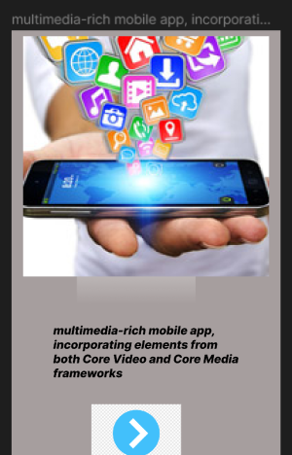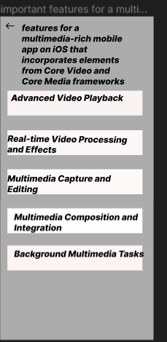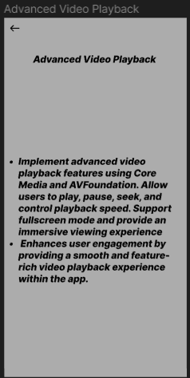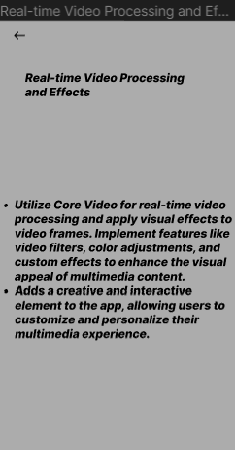

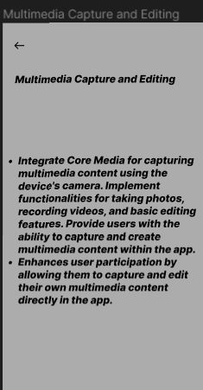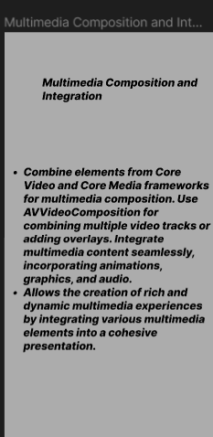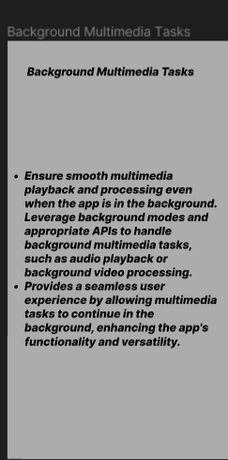

**Prototype:**

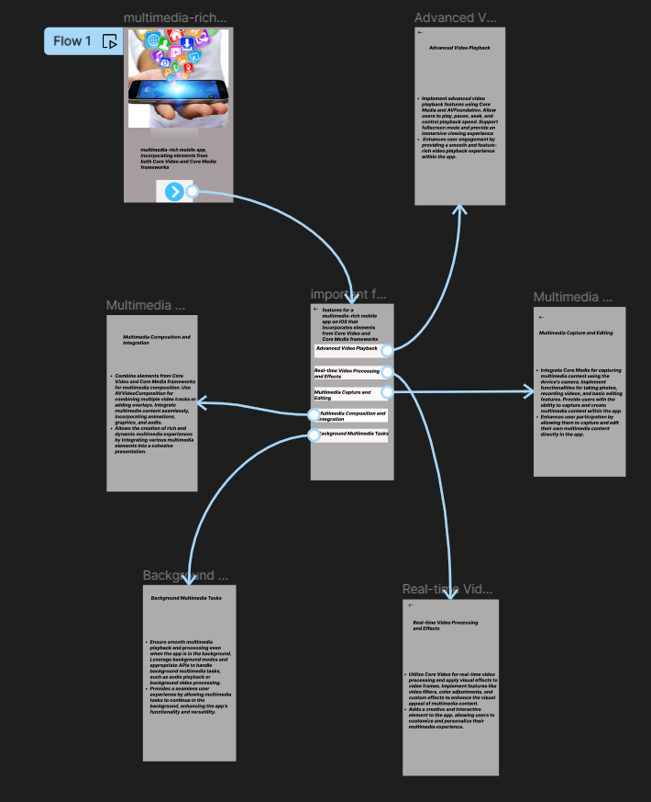

**Result:** A wireframe for a multimedia-rich mobile app, incorporating elements from both Core Video and Core Media frameworks using figma have been created successfully